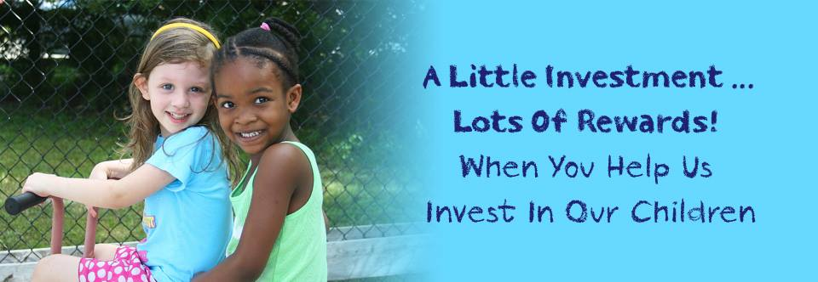
The Florida Center Wish List
Throughout The Florida Center, there are projects both big and small that make a huge impact on our students, clients and families. By providing some of these items and projects, you are investing in the next generation, and allowing them to learn, reach milestones, and lay the foundation for a successful future.
Mental Health Items:
Our team consists of 14 clinicians. We have 9 play therapy offices, 2 adult therapy offices, and 2 observation rooms. Our offices are located in Sarasota and North Port. Because we serve so many families, we’ve “wished” for several of the same items. We share toys when we can, but it’s not always possible.
- 4 sets of solid wood child-sized tables and chairs (Amazon)
- 5x7 Rugs (gender/age neutral) (Amazon)
- 6 Hape All Seasons Kid's Wooden Doll House Furnished with Accessories (Amazon $103.07 Each)
- 6 Hape Caucasian family dolls (Amazon $13.35 Each)
- 6 Hape African American family dolls (Amazon)
- 6 Hape Asian family dolls (Amazon)
- 6 Hape Wooden Doll House Furniture Family Car Play Set (Amazon $15.98 Each)
- 2 GOPRO Hero (Wifi Enabled) (Amazon $200-300)
- Sensei Play and Learn Finger Puppets (Amazon $8.99 Each)
- Miniature Court Room (http://www.theraplay.com/municipal-bldgs/stores/courtroom-complete/ $175)
- 2 Meebie play therapy doll (Amazon $119)
- 4 Learning Resources Jungle (Amazon $16 Each)
- 6 B. Doctor Set Wee MD. Play Doctor Kit (Amazon $30 each)
- Animals set of 60
- Play-doh
- Arts and crafts supplies
- Baby dolls (various races)
- Emergency vehicles (toys, ambulance, police car, fire truck)
Starfish Academy and Developmental Therapies:
- Magazine racks for the lobby (Amazon, around $70-$100)
- New rugs and toys in the lobby, especially a new Lego table (Wal-Mart, $70)
- New rugs in classrooms-colorful and fun
- Big Cubbie Storage- $283.99 (#XSWP1413-Discount School Supply)
- Chairs-$194.99 (DSC121C5) set of 5 (From Discount School Supply)
- Light Covers-$39.99 (AP92301) (From Discount School Supply)
- Developmentally-appropriate playground toys and equipment – Estimated cost: $50 - $7,000 The playground has push toys, ride-alongs and other smaller, less expensive pieces that continually need replaced due to weather and wear and tear. The playground could also use several large pieces that need to be installed in-ground and can cost upwards of $7,000-$10,000. Replacing wood mulch with rubberized mulch is also a “wish” that is currently unfunded. Any donation could go towards this future project.

Projects:
- Family Sensitive Bathrooms
- Impact: Having tidy, parent and child- friendly public bathrooms is important because we serve many infants, young children and their family members. Many of the people we serve have disabilities. Often, parents have more than one child with them. Bathroom time can be stressful and it’s important our public restrooms are clean and ready for families. We’d like to update the counter tops and sinks, and improve the functionality of the bathrooms.
- Videotaping (with audio) technology equipment and installation
- Impact: We conduct several videotaped observations of parent-child relationships every day. This is our specialty! Observation spaces are shared by all therapists in both locations. Our technology is in need of updating, including the videotaping and audio equipment and how we store our data. (We would like a secure way to save these observations vs. using a DVD for each observation which is costly.)
- Updated lighting
- Impact: Our lighting is old and outdated. Some of our overhead lights are working, but some aren’t. Help us update our offices by switching to family friendly lighting, like track lighting.
- Repainting the hallway
- Impact: Half of our hallway has been updated to a cheerful yellow color. We’re almost there!
- Planting by the back door
- Impact: Can you help us “grow?” Our families often leave through our “back door” and it would be so nice to have some colorful bushes or flowers along the pathway.

